Seventeenth Annual

Nationwide Relocating Employee Survey©

Results for 2011

BUDD VAN LINES

Prepared for:
Mr. Gary Grund
July, 2011
BACKGROUND INFORMATION
The seventeenth annual Nationwide Relocating Employee Survey © was conducted throughout a six month period ending June 30, 2011. The overall purpose of this annual survey is to collect and report objective, unbiased evaluations from domestic transferees regarding their level of satisfaction with external relocation service providers used in the transfer.
Surveying for the Nationwide Relocating Employee Survey© seeks opinions of relocated employees via telephone or the Internet using web-surveys. The data is collected from (a) relocated employees working for clients of Trippel Survey & Research, LLC as part of the ongoing survey relationships, and (b) from one-time corporate client studies performed for the purpose of this annual industry research.
One standard question is asked of each customer regarding satisfaction with each of the suppliers used in the individual’s transfer. The core question is “Evaluate your overall level of service satisfaction with [this supplier’s] performance?” A ten-point scale is used where 10 is the highest score of satisfaction, 1 is the lowest score.
Supplier overall performance is evaluated using two metrics: average score and net satisfaction. Average satisfaction is a strict mean score not weighted by volume. Net satisfaction is a measurement commonly used in qualitative surveys measuring the difference between top block scores of 10 or 9 and bottom block scores of 1 through 6.
Many corporations, as part of an ongoing survey relationship with Trippel Survey & Research LLC, request additional questions of their employees. The responses to those company-specific questions are confidential to those companies and not included in this report.
The survey data collection ended June 30, 2011. The survey accumulated opinions from 7298 transferees representing 110 companies. There is a small margin of sampling error in all service categories, but does not materially impact the relative ranking of the firms reported.

CONFIDENTIALITY

The information provided is the property of Trippel Survey & Research, LLC and may only be distributed to personnel employed by Budd Van Lines. You may only share the report among current employees.
All material contained herein is copyright © 2011 by Trippel Survey & Research, LLC. All Rights Reserved. Non-participating relocation managers and service providers may purchase a copy of the report by submitting a written request to Trippel Survey & Research, LLC at alantrippel@att.net or calling 501-922-4000.

TABLE OF CONTENTS

TOPIC PAGE
Executive Summary 3

Summary of performance results,
all service categories for 2011 4

Changes in transferee satisfaction (trends),
all service categories, recent 5 years 5

Performance of service firms, by category:
Household Goods (HHG) 6
Relocation Management
Company (RMC) 8
Relocation Mortgage 11
Spouse-Partner-Family 13
Temporary Housing 15
EXECUTIVE SUMMARY

- Over 7298 transferees’ evaluations are recorded in this survey. This represents a 0.4% decrease from a year ago.
- The most significant demographic this year was a large number of homeowners participating in the survey compared to renters. The mix of homeowners to renters exceeded a 3.4-to-1 ratio. This was the highest ratio of homeowners-to-renters in the past 17 annual surveys.
- For the fifth consecutive year, renters are more satisfied than homeowners with the overall relocation experience and the performance of relocation service providers.
- Of the five industries evaluated by transferees three industries showed a small improvement in transferee satisfaction from last year: Relocation Management Services, Mortgage Services and Temporary Housing services. Two industries, Household Goods services, Spouse-Partner-Family services, performed generally the same as a year ago. No industry showed a decrease in transferee satisfaction.
- In the HHG industry Atlas earned the top evaluation results, with Clark & Reid and Budd close behind.
- In the Relocation Management Services industry Altair earned the highest satisfaction ratings, with Plus and Cartus rounding out the highest three performers.
- In the Mortgage industry Premia Mortgage achieved the highest transferee satisfaction score; Huntington and Chase following in the top three scorers.
- In the Spouse-Partner-Family services industry Sally White & Associates had the highest average score while Vandover earned the highest net satisfaction percentage. Both firms were significantly ahead of the other service providers.
- In the Temporary Housing industry Oakwood Worldwide and Residence Inns earned top two performance scores.

SATISFACTION WITH THE ENTIRE RELOCATION EXPERIENCE

This year’s survey inquired on transferees’ overall satisfaction with the entire relocation experience.
 | Number | Average | Top | Bottom | Net
 | Surveys | Score | Block | Block | Satisfaction
TOTAL | 7216 | 7.74 | 44% | 23% | 21%

The evaluations indicate a passive level of satisfaction with their relocation experience with an average score of 7.74. This is lower than last year’s result of 7.95 average score.
Further, the net satisfaction of 21% is also lower than last year’s result of 31% net satisfaction. This reinforces transferees’ mediocre levels of satisfaction with the relocation experience.
The range of scores was a low of 7.07 to a high of 8.82 among all 110 companies. Less than one-half the transferees rated the overall relocation experience with a top block score, and over one in five gave a bottom block score (1 through 6 on 10-point scale). No company’s transferees collectively rated the relocation experience as “top block.”

The reason for the general mild level of transferee satisfaction – or mild dissatisfaction – might be found in performance of firms in the 5 key industries noted in the report. Further, when performance of many service providers are pooled with the continued slump in the housing market impacting home sellers and difficulties of renters (potential home buyers) with tight credit restrictions there is a perfect storm of forces creating the overall malaise transferees are opining with the relocation experience.

SUMMARY OF SURVEY RESULTS –
ALL RELOCATION RELATED INDUSTRIES

 | Number | Average | Top | Bottom | Net
Industry | Evaluations | Score | Block | Block | Satisfaction
Household Goods | 7220 | 8.04 | 50% | 15% | 35%
Relocation Mgmt. Companies | 7197 | 7.98 | 44% | 12% | 32%
Mortgage Companies | 6821 | 8.11 | 46% | 10% | 36%
Spouse-Partner Services | 985 | 7.42 | 33% | 19% | 14%
Temporary Housing | 4376 | 8.15 | 48% | 9% | 40%

Among the 7298 total transferring employee providing evaluations on various service providers in five industries, temporary housing services and the mortgage services industry scored the highest in average score and net satisfaction. Transferees expressed the most dissatisfaction with spouse-partner services industry.

AVERAGE SCORE (10 high, 1 low):
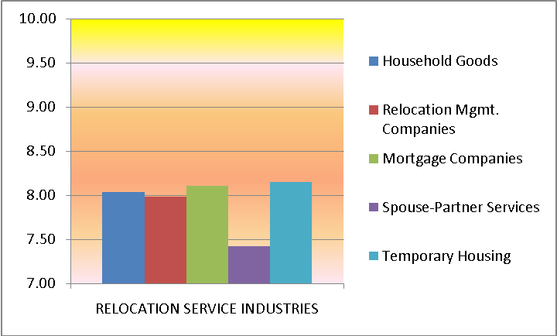

NET SATISFACTION (100% high, -100% low)
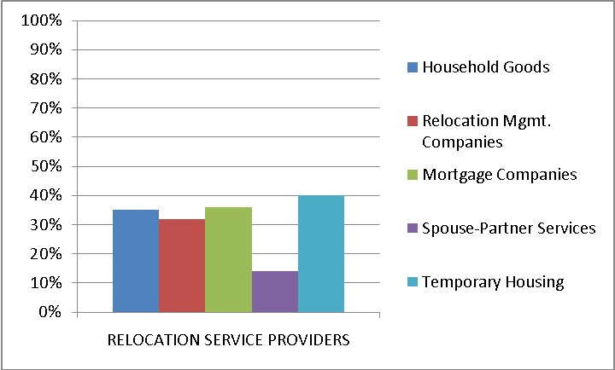

CHANGES IN CUSTOMER SATISFACTION OVER RECENT YEARS

The transferee satisfaction scores during the recent five year period show minimal volatility. Both the average score and net satisfaction percentage charts below demonstrate moderate changes in year-to-year performance for each of the five industries.

The Household Goods Shipment industry has realized relatively flat five-year performance compared to the other industries. The Spouse-Partner Services industry has witnessed a precipitous decline over the five-year period while the Mortgage industry has bounced back from the low evaluations two years ago.

AVERAGE SCORE (10 high, 1 low):
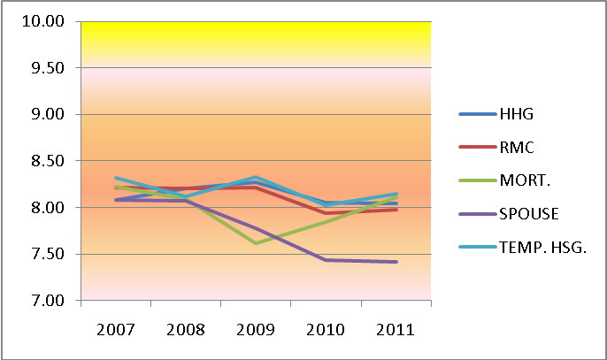

NET SATISFACTION (100% high, -100% low):
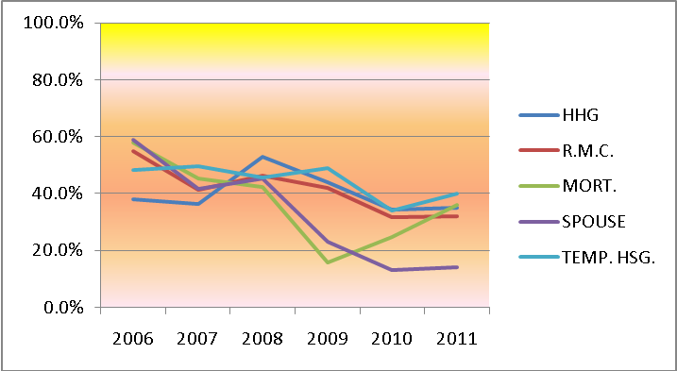

1. HOUSEHOLD GOODS SHIPMENT
Household Goods firms included in the chart below are among the largest firms in this service industry. Each of these firms recorded over 100 transferee surveys representing 5 or more corporations. Many transferees’ evaluations serviced by smaller firms are included in the chart in the all others category due to small sample sizes. Survey respondents include any transferred employee serviced by the company regardless of size of load or whether the activity was pack & load, delivery, or both ends of the move; both homeowners and renters. Suppliers are shown in descending order by average score; all scores and metrics are shown.

 | Scores > |  |  |  |  |  |  |  |  |  | Total | Aver. | Top | Bottom | Net
 | 1 | 2 | 3 | 4 | 5 | 6 | 7 | 8 | 9 | 10 | Surveys | Score | Block % | Block % | Satis. %
Atlas Van Lines | 12 | 13 | 7 | 2 | 19 | 22 | 85 | 124 | 240 | 202 | 726 | 8.35 | 61% | 10% | 51%
Clark & Reid | 6 | 2 | 3 | 0 | 8 | 6 | 22 | 29 | 47 | 71 | 194 | 8.32 | 61% | 13% | 48%
Budd Van Lines | 8 | 6 | 5 | 9 | 19 | 16 | 35 | 71 | 141 | 132 | 442 | 8.29 | 62% | 14% | 48%
New World Van Lines | 11 | 6 | 0 | 2 | 8 | 13 | 49 | 106 | 139 | 73 | 407 | 8.16 | 52% | 10% | 42%
United Van Lines | 26 | 29 | 18 | 16 | 59 | 61 | 173 | 371 | 384 | 404 | 1541 | 8.14 | 51% | 14% | 38%
Allied Worldwide | 21 | 15 | 6 | 8 | 24 | 17 | 57 | 131 | 203 | 171 | 653 | 8.13 | 57% | 14% | 43%
Wheaton Van Lines | 11 | 6 | 0 | 2 | 8 | 9 | 14 | 80 | 119 | 43 | 292 | 8.10 | 55% | 12% | 43%
NorthAmerican | 8 | 6 | 5 | 9 | 16 | 7 | 52 | 61 | 103 | 97 | 364 | 8.08 | 55% | 14% | 41%
Graebel Company | 6 | 3 | 2 | 4 | 10 | 5 | 45 | 75 | 60 | 55 | 265 | 8.00 | 43% | 11% | 32%
Stevens Van Lines | 3 | 2 | 1 | 1 | 5 | 5 | 16 | 23 | 45 | 18 | 119 | 7.98 | 53% | 14% | 39%
Paul Arpin Van Lines | 3 | 3 | 2 | 0 | 3 | 10 | 51 | 85 | 60 | 27 | 244 | 7.94 | 36% | 9% | 27%
Mayflower | 7 | 6 | 1 | 8 | 15 | 21 | 67 | 76 | 83 | 62 | 346 | 7.80 | 42% | 17% | 25%
Others not listed | 27 | 22 | 21 | 41 | 124 | 106 | 267 | 383 | 335 | 301 | 1627 | 7.69 | 39% | 21% | 18%
HHG INDUSTRY> | 149 | 119 | 71 | 102 | 318 | 298 | 933 | 1615 | 1959 | 1656 | 7220 | 8.04 | 50% | 15% | 35%
 |  |  |  |  |  |  |  |  | AVERAGE SCORE |  |  | 8.04
 |  |  |  |  |  |  |  |  |  | TOP BLOCK |  | 50%
 |  |  |  |  |  |  |  |  | BOTTOM BLOCK |  |  | 15%
 |  |  |  |  |  |  |  |  | NET SATISFACTION |  |  | 35%

Atlas Van Lines achieved the highest average score and the highest net satisfaction percentage.

No firm achieved the “excellence” metric of 9.0 average score or 70% net satisfaction percentage. The following chart shows average scores for the industry carriers.
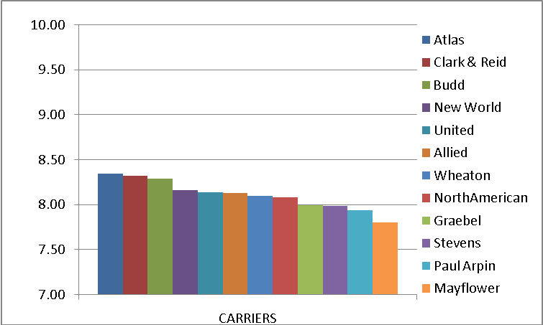

Over the last five years there are measureable changes in many carriers’ performance in transferee satisfaction. The graph shows the yearly average score of seven firms with the largest survey-share over the five year period.

AVERAGE SCORES
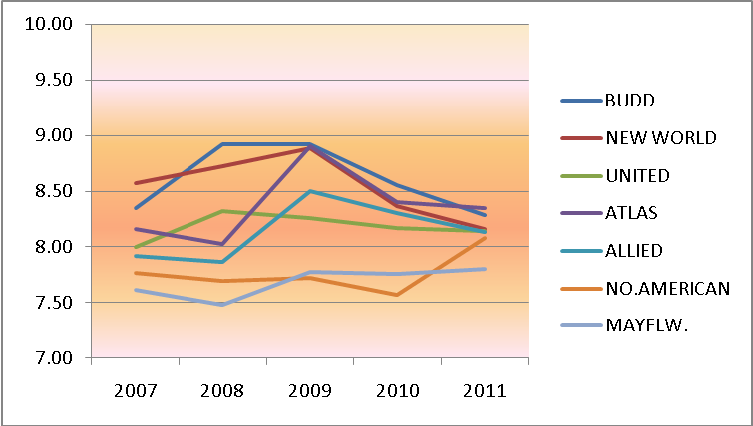

Among the largest survey-share firms, NorthAmerican Van Lines showed the greatest improvement in transferee satisfaction this past year. A couple firms realized a decline in satisfaction while a few were relatively flat to the past year or two.

Another noticeable trend is the narrowing of the differences in highest-to-lowest satisfaction scores in recent years. This indicates there is less competitive differentiation from the viewpoint of transferee satisfaction.

Over an 11-year period the entire industry has demonstrated moderate volatility, with a general improvement in transferee satisfaction. Chart shows average scores.
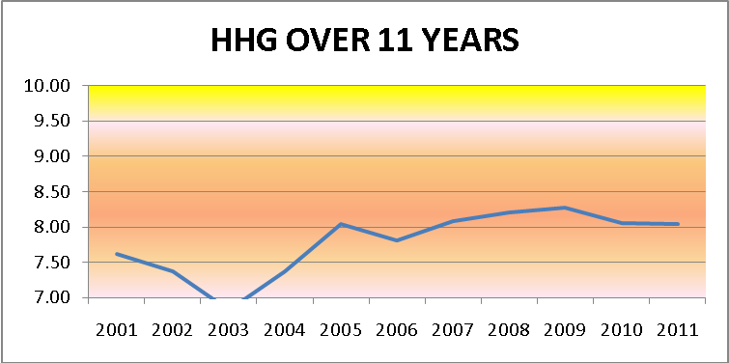

2. RELOCATION MANAGEMENT COMPANIES
Relocation Management Companies (RMC) firms included in the chart below are the largest firms in the industry and each firm recorded over 100 surveyed transferees. Evaluations of very small RMC firms (under 100 surveys) are included in the all other category due to small sample sizes.
Transferees in this survey include any transferred employee regardless of home owner and renter status, and regardless of policy program received from the employer. Suppliers are shown in descending order by average score; all scores and metrics are shown

 | Scores > |  |  |  |  |  |  |  |  |  | Total | Aver. | Top | Bottom | Net
 | 1 | 2 | 3 | 4 | 5 | 6 | 7 | 8 | 9 | 10 | Surveys | Score | Block % | Block % | Satis. %
Altair Global | 3 | 3 | 5 | 8 | 13 | 8 | 56 | 66 | 91 | 82 | 335 | 8.14 | 52% | 12% | 40%
Plus Relocation | 3 | 1 | 2 | 1 | 11 | 3 | 22 | 40 | 37 | 41 | 161 | 8.11 | 48% | 13% | 35%
Cartus | 41 | 22 | 17 | 29 | 96 | 47 | 389 | 432 | 544 | 507 | 2124 | 8.08 | 49% | 12% | 38%
NEI Relocation | 3 | 4 | 1 | 1 | 6 | 3 | 31 | 54 | 45 | 38 | 186 | 8.06 | 45% | 10% | 35%
SIRVA Relocation | 5 | 11 | 5 | 6 | 22 | 16 | 179 | 223 | 178 | 144 | 789 | 8.05 | 41% | 8% | 33%
Prudential Relocation | 8 | 6 | 5 | 9 | 32 | 14 | 209 | 211 | 182 | 171 | 847 | 8.04 | 42% | 9% | 33%
Weichert Relo. Res. | 5 | 9 | 5 | 9 | 31 | 12 | 117 | 155 | 140 | 129 | 612 | 8.02 | 44% | 12% | 32%
TRC | 2 | 3 | 1 | 2 | 3 | 6 | 35 | 34 | 36 | 32 | 154 | 7.99 | 44% | 11% | 33%
WHR Group | 2 | 2 | 0 | 1 | 4 | 2 | 23 | 28 | 29 | 18 | 109 | 7.96 | 43% | 10% | 33%
Brookfield GRS | 5 | 2 | 1 | 3 | 17 | 11 | 86 | 91 | 78 | 64 | 358 | 7.95 | 40% | 11% | 29%
Paragon Global Res. | 4 | 1 | 0 | 0 | 5 | 5 | 27 | 35 | 37 | 19 | 133 | 7.92 | 42% | 11% | 31%
MSI | 4 | 1 | 0 | 0 | 9 | 3 | 17 | 25 | 32 | 21 | 112 | 7.91 | 47% | 15% | 32%
Lexicon | 1 | 1 | 1 | 2 | 6 | 3 | 27 | 28 | 27 | 16 | 112 | 7.84 | 38% | 13% | 26%
ACS (Xerox) | 2 | 2 | 0 | 0 | 5 | 5 | 36 | 28 | 29 | 16 | 123 | 7.79 | 37% | 11% | 25%
The MIGroup | 7 | 4 | 2 | 1 | 11 | 6 | 33 | 51 | 41 | 32 | 188 | 7.68 | 39% | 16% | 22%
Graebel Relocation | 11 | 5 | 1 | 7 | 19 | 14 | 72 | 83 | 68 | 49 | 329 | 7.60 | 36% | 17% | 18%
AIReS | 6 | 3 | 1 | 1 | 12 | 5 | 41 | 28 | 32 | 14 | 143 | 7.33 | 32% | 20% | 13%
Others not listed | 3 | 10 | 5 | 6 | 28 | 14 | 66 | 91 | 82 | 77 | 382 | 7.81 | 42% | 17% | 24%
R.M.C. INDUSTRY> | 115 | 90 | 52 | 86 | 330 | 177 | 1466 | 1703 | 1708 | 1470 | 7197 | 7.98 | 44% | 12% | 32%
 |  |  |  |  |  |  |  |  | AVERAGE SCORE |  |  | 7.98
 |  |  |  |  |  |  |  |  |  | TOP BLOCK |  | 44%
 |  |  |  |  |  |  |  |  | BOTTOM BLOCK |  |  | 12%
 |  |  |  |  |  |  |  |  | NET SATISFACTION |  |  | 32%

Among the larger service firms Altair Global Relocation earned the largest average score and the highest net satisfaction percentage. Among the other large firms, Cartus earned second highest scores. Among the smaller service firms Plus Relocation earned high scores with NEI a close second in key metrics.

The following chart and graphic show the average score for the seven firms with the largest survey size firms, each recoding more than 300 surveys from a minimum of 5 companies.

 | Scores > |  |  |  |  |  |  |  |  |  | Total | Aver. | Top | Bottom | Net
 | 1 | 2 | 3 | 4 | 5 | 6 | 7 | 8 | 9 | 10 | Surveys | Score | Block % | Block % | Satis. %
Altair Global | 3 | 3 | 5 | 8 | 13 | 8 | 56 | 66 | 91 | 82 | 335 | 8.14 | 52% | 12% | 40%
Cartus | 41 | 22 | 17 | 29 | 96 | 47 | 389 | 432 | 544 | 507 | 2124 | 8.08 | 49% | 12% | 38%
SIRVA Relocation | 5 | 11 | 5 | 6 | 22 | 16 | 179 | 223 | 178 | 144 | 789 | 8.05 | 41% | 8% | 33%
Prudential Relo. | 8 | 6 | 5 | 9 | 32 | 14 | 209 | 211 | 182 | 171 | 847 | 8.04 | 42% | 9% | 33%
W.R.R.I. | 5 | 9 | 5 | 9 | 31 | 12 | 117 | 155 | 140 | 129 | 612 | 8.02 | 44% | 12% | 32%
Brookfield GRS | 5 | 2 | 1 | 3 | 17 | 11 | 86 | 91 | 78 | 64 | 358 | 7.95 | 40% | 11% | 29%
Graebel Relo. | 11 | 5 | 1 | 7 | 19 | 14 | 72 | 83 | 68 | 49 | 329 | 7.60 | 36% | 17% | 18%

See graphic on next page.
AVER. SCORE – 7 LARGEST FIRMS
The following chart and graphic shows average score for the smaller firms with 300 or fewer surveys from a minimum of 3 corporations each.

 | Scores > |  |  |  |  |  |  |  |  |  | Total | Aver. | Top | Bottom | Net
 | 1 | 2 | 3 | 4 | 5 | 6 | 7 | 8 | 9 | 10 | Surveys | Score | Block % | Block % | Satis. %
Plus Relocation | 3 | 1 | 2 | 1 | 11 | 3 | 22 | 40 | 37 | 41 | 161 | 8.11 | 48% | 13% | 35%
NEI Relocation | 3 | 4 | 1 | 1 | 6 | 3 | 31 | 54 | 45 | 38 | 186 | 8.06 | 45% | 10% | 35%
TRC | 2 | 3 | 1 | 2 | 3 | 6 | 35 | 34 | 36 | 32 | 154 | 7.99 | 44% | 11% | 33%
WHR Group | 2 | 2 | 0 | 1 | 4 | 2 | 23 | 28 | 29 | 18 | 109 | 7.96 | 43% | 10% | 33%
Paragon Global | 4 | 1 | 0 | 0 | 5 | 5 | 27 | 35 | 37 | 19 | 133 | 7.92 | 42% | 11% | 31%
MSI | 4 | 1 | 0 | 0 | 9 | 3 | 17 | 25 | 32 | 21 | 112 | 7.91 | 47% | 15% | 32%
Lexicon | 1 | 1 | 1 | 2 | 6 | 3 | 27 | 28 | 27 | 16 | 112 | 7.84 | 38% | 13% | 26%
ACS (Xerox) | 2 | 2 | 0 | 0 | 5 | 5 | 36 | 28 | 29 | 16 | 123 | 7.79 | 37% | 11% | 25%
The MIGroup | 7 | 4 | 2 | 1 | 11 | 6 | 33 | 51 | 41 | 32 | 188 | 7.68 | 39% | 16% | 22%
AIReS | 6 | 3 | 1 | 1 | 12 | 5 | 41 | 28 | 32 | 14 | 143 | 7.33 | 32% | 20% | 13%

AVER. SCORE – 10 SMALLER FIRMS
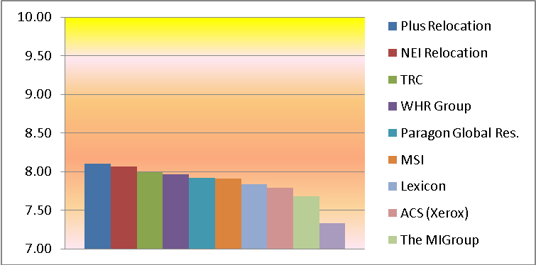

Over the last 11 year period there has was overall improvement in transferee satisfaction through the period beginning with the housing recession, then recently a moderate decline in transferee satisfaction the last couple years.

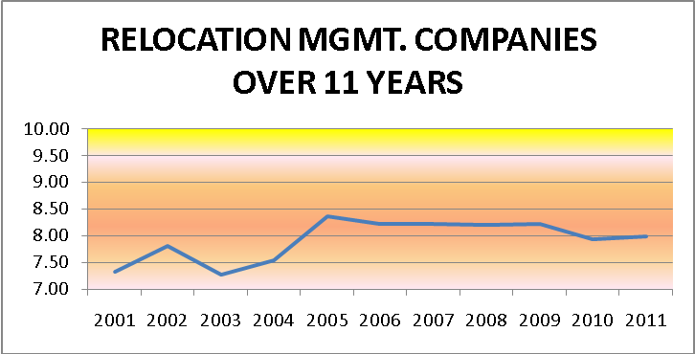

3. RELOCATION MORTGAGE PROVIDERS

Relocation Mortgage firms included in the chart below are among the eleven largest firms in the industry and each firm had over 200 surveyed transferees from multiple companies. Evaluations of smaller mortgage firms are included in the all other category due to small sample sizes of transferees. Suppliers are shown in descending order by average score; all scores and metrics are shown.

 | Scores > |  |  |  |  |  |  |  |  |  | Total | Average | Top | Bottom | Net
 | 1 | 2 | 3 | 4 | 5 | 6 | 7 | 8 | 9 | 10 | Surveys | Score | Block % | Block % | Satis. %
Premia Mortgage | 3 | 5 | 2 | 1 | 11 | 4 | 64 | 67 | 104 | 89 | 350 | 8.32 | 55% | 7% | 48%
Huntington Mortgage | 4 | 2 | 2 | 1 | 8 | 5 | 55 | 54 | 83 | 71 | 285 | 8.29 | 54% | 8% | 46%
Chase (JP Morgan) | 2 | 4 | 2 | 1 | 12 | 6 | 86 | 93 | 97 | 87 | 390 | 8.22 | 47% | 7% | 40%
Sirva Mortgage | 2 | 7 | 2 | 1 | 8 | 2 | 69 | 78 | 77 | 78 | 324 | 8.20 | 48% | 7% | 41%
Wells Fargo Hm. Ln. | 21 | 27 | 16 | 14 | 56 | 52 | 213 | 371 | 371 | 407 | 1548 | 8.16 | 50% | 12% | 38%
Weichert Financial | 2 | 5 | 4 | 4 | 16 | 8 | 47 | 62 | 84 | 76 | 308 | 8.15 | 52% | 13% | 39%
CitiMortgage | 7 | 6 | 1 | 2 | 10 | 16 | 201 | 187 | 169 | 146 | 745 | 8.13 | 42% | 6% | 37%
Cartus Home Loan | 4 | 7 | 5 | 9 | 19 | 14 | 136 | 172 | 153 | 137 | 656 | 8.11 | 44% | 9% | 35%
Quicken Loans | 3 | 3 | 1 | 2 | 10 | 3 | 41 | 52 | 47 | 44 | 206 | 8.03 | 44% | 11% | 33%
Regions Bank | 3 | 4 | 1 | 1 | 6 | 3 | 34 | 57 | 42 | 35 | 186 | 8.00 | 41% | 10% | 32%
Bank America | 11 | 18 | 11 | 10 | 37 | 21 | 274 | 278 | 259 | 219 | 1138 | 7.99 | 42% | 9% | 33%
US Bank | 6 | 2 | 1 | 3 | 12 | 7 | 72 | 83 | 68 | 49 | 303 | 7.91 | 39% | 10% | 28%
Others not listed | 3 | 10 | 5 | 6 | 28 | 14 | 66 | 91 | 82 | 77 | 382 | 7.81 | 42% | 17% | 24%
MORTGAGE INDUSTRY> | 71 | 100 | 53 | 55 | 233 | 155 | 1358 | 1645 | 1636 | 1515 | 6821 | 8.11 | 46% | 10% | 36%
 |  |  |  |  |  |  |  |  | AVERAGE SCORE |  |  | 8.11
 |  |  |  |  |  |  |  |  |  | TOP BLOCK |  | 46%
 |  |  |  |  |  |  |  |  | BOTTOM BLOCK |  |  | 10%
 |  |  |  |  |  |  |  |  | NET SATISFACTION |  |  | 36%

This year Premia Mortgage earned the highest average score and net satisfaction percentage among all mortgage providers. The data above is displayed in the graphic below, using average scores.

AVERAGE SCORES
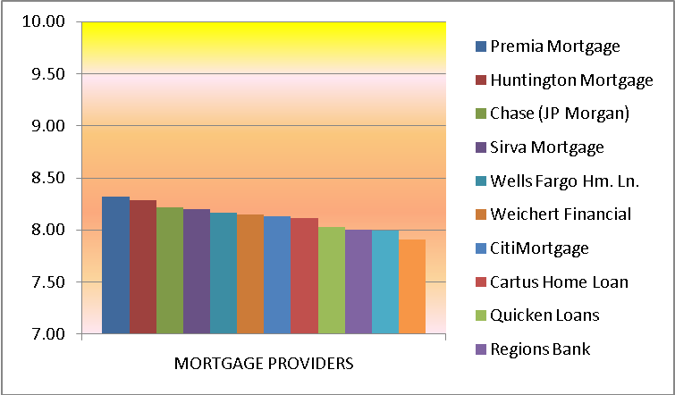

The largest firms over the past five years of survey date are shown below.

The following chart shows the largest survey-share mortgage providers’ average score over a six year period. There was a sharp decrease in transferee satisfaction hitting bottom at the height of the real estate and financial crisis. Over the last two years transferee satisfaction improved.
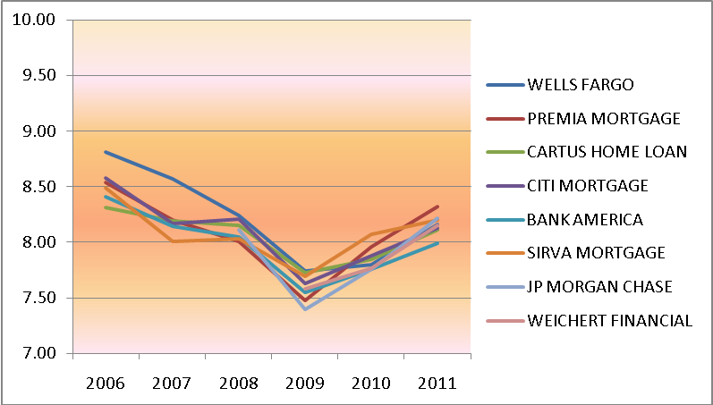

Two trends are revealed in the chart above. One, the industry competitors’ performance follow parallel paths – no firm is able to stand out in boom or bust periods. Two, whereas Wells Fargo Home Loans had a strong differentiation in transferee satisfaction that is no longer true. In fact from the perspective of transferees satisfaction there is little differentiation among the top mortgage providers.

Over the last 11 years the industry has demonstrated volatile performance satisfying transferees. The low mark was achieved two years ago and improvement over the period since. The housing market in the United States peaked in late 2007 and as the performance chart indicates the precipitous decline accelerated the 2 years following.
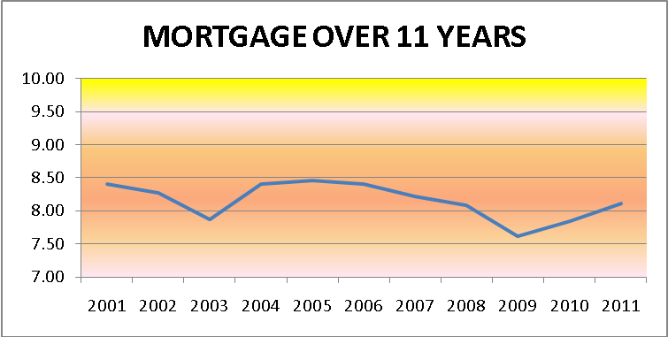

4. SPOUSE-PARTNER-FAMILY SERVICES
Seven of the largest service providers in the spouse-partner services are shown below. Please review this information with caution because a few firms have small sample sizes. Suppliers are shown in descending order by average score; all scores and metrics are shown.

 | Scores |  |  |  |  |  |  |  |  |  | Total | Aver. | Top | Bottom | Net
 | 1 | 2 | 3 | 4 | 5 | 6 | 7 | 8 | 9 | 10 | Surveys | Score | Block % | Block % | Satis. %
Sally White & Assoc | 4 | 7 | 1 | 2 | 10 | 4 | 57 | 51 | 41 | 38 | 215 | 7.72 | 37% | 13% | 24%
Vandover | 5 | 6 | 4 | 0 | 8 | 6 | 49 | 37 | 38 | 39 | 192 | 7.69 | 40% | 15% | 25%
Impact Group | 8 | 9 | 4 | 4 | 27 | 11 | 67 | 62 | 54 | 46 | 292 | 7.42 | 34% | 22% | 13%
Ricklin-Echikson & As. | 1 | 4 | 0 | 0 | 8 | 2 | 27 | 21 | 14 | 6 | 83 | 7.28 | 24% | 18% | 6%
Lee Hecht Harrison | 2 | 2 | 0 | 0 | 3 | 1 | 16 | 9 | 7 | 3 | 43 | 7.07 | 23% | 19% | 5%
Options Res. Careers | 3 | 2 | 0 | 0 | 5 | 3 | 16 | 12 | 9 | 4 | 54 | 7.02 | 24% | 24% | 0%
Right Management | 4 | 3 | 1 | 1 | 8 | 2 | 23 | 11 | 5 | 2 | 60 | 6.38 | 12% | 32% | -20%
Others not listed | 1 | 2 | 2 | 1 | 3 | 1 | 12 | 9 | 8 | 7 | 46 | 7.26 | 33% | 22% | 11%
INDUSTRY> | 28 | 35 | 12 | 8 | 72 | 30 | 267 | 212 | 176 | 145 | 985 | 7.42 | 33% | 19% | 14%
 |  |  |  |  |  |  |  |  | AVERAGE SCORE |  |  | 7.42
 |  |  |  |  |  |  |  |  |  | TOP BLOCK |  | 33%
 |  |  |  |  |  |  |  |  | BOTTOM BLOCK |  |  | 19%
 |  |  |  |  |  |  |  |  | NET SATISFACTION |  |  | 14%

This year Sally White & Associates earned the highest transferee satisfaction ratings by a small margin over Vandover. Further, Sally White was the only firm to show measurable improvement from the prior survey. These two firms, Sally White & Associates and Vandover are significantly ahead of competitors in transferee satisfaction.

The following graphic shows the 6 largest firms in the industry.
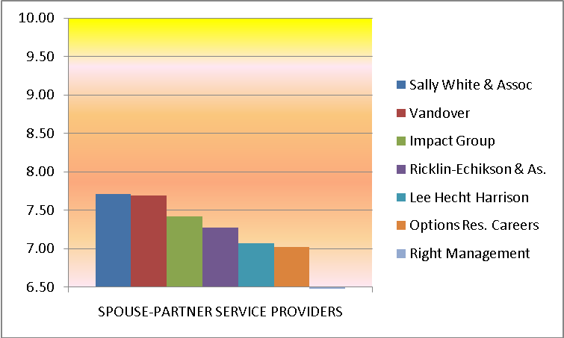

The chart on the next page shows the recent six-year trend of the largest firms in this industry, exressed by average score.

AVERAGE SCORES OVER 6 YEARS
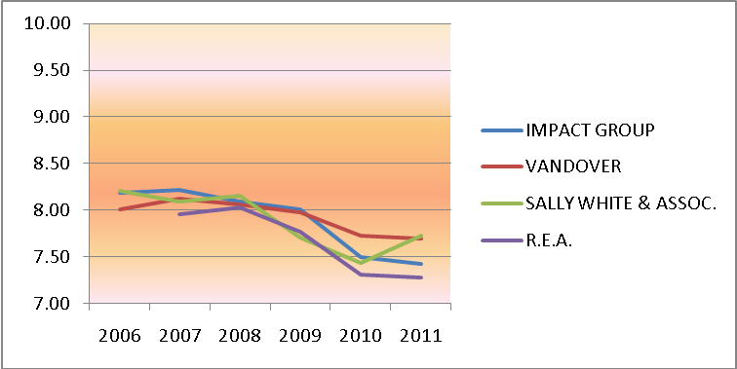

With the exception of one firm, the three largest service providers have maintained a tight hold on best transferee satisfaction the past six years.

The industry as a whole has shown minimal volatility in transferee satisfaction over an 11-year period. There was a steady, slow improvement in transferee satisfaction for the first part of the decade and a recent three year decline mirroring the general economic recession in the country.

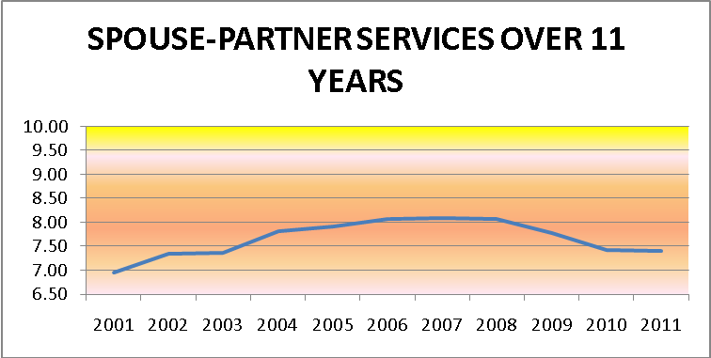

5. TEMPORARY HOUSING SERVICES
Firms providing temporary housing services to the transferee are included in the chart below. Evaluations of dozens of smaller temporary housing service firms are included in the all other category due to small transferee sample sizes. Note, once again, a few firms have small sample sizes. Suppliers are shown in descending order by average score; all scores and metrics are shown.

 | Scores > |  |  |  |  |  |  |  |  |  | Total | Aver. | Top | Bottom | Net
 | 1 | 2 | 3 | 4 | 5 | 6 | 7 | 8 | 9 | 10 | Surveys | Score | Block % | Block % | Satis. %
Oakwood Worldwide | 11 | 17 | 5 | 2 | 42 | 11 | 241 | 260 | 433 | 355 | 1377 | 8.39 | 57% | 6% | 51%
Residence Inn | 1 | 2 | 0 | 0 | 5 | 2 | 22 | 26 | 51 | 29 | 138 | 8.36 | 58% | 7% | 51%
Hampton Corp. Suites | 2 | 1 | 1 | 1 | 4 | 1 | 29 | 33 | 43 | 31 | 146 | 8.23 | 51% | 7% | 44%
Suite America | 0 | 2 | 0 | 1 | 4 | 0 | 27 | 35 | 35 | 23 | 127 | 8.20 | 46% | 6% | 40%
Weichert Corp. Hous'g. | 3 | 2 | 1 | 1 | 3 | 2 | 29 | 31 | 46 | 30 | 148 | 8.15 | 51% | 8% | 43%
Marriott ExecuStay | 5 | 7 | 2 | 4 | 22 | 7 | 135 | 167 | 146 | 131 | 626 | 8.14 | 44% | 8% | 37%
DJK Residential | 0 | 1 | 0 | 0 | 6 | 1 | 18 | 22 | 30 | 11 | 89 | 8.09 | 46% | 9% | 37%
BridgeStreet World. | 1 | 1 | 0 | 0 | 7 | 1 | 22 | 23 | 27 | 16 | 98 | 8.01 | 44% | 10% | 34%
Corporate Living | 1 | 1 | 0 | 0 | 7 | 2 | 22 | 23 | 29 | 14 | 99 | 7.97 | 43% | 11% | 32%
Amber Lodging | 2 | 1 | 0 | 1 | 6 | 1 | 21 | 22 | 26 | 17 | 97 | 7.95 | 44% | 11% | 33%
Equity Corp. Housing | 4 | 1 | 0 | 0 | 8 | 3 | 16 | 22 | 32 | 21 | 107 | 7.94 | 50% | 15% | 35%
Extended Stay Amer. | 2 | 3 | 0 | 0 | 5 | 1 | 17 | 24 | 26 | 17 | 95 | 7.94 | 45% | 12% | 34%
Churchill | 2 | 1 | 0 | 1 | 6 | 2 | 21 | 24 | 27 | 15 | 99 | 7.90 | 42% | 12% | 30%
Others not listed | 11 | 18 | 9 | 11 | 46 | 36 | 267 | 275 | 248 | 209 | 1130 | 7.92 | 40% | 12% | 29%
INDUSTRY> | 45 | 58 | 18 | 22 | 171 | 70 | 887 | 987 | 1199 | 919 | 4376 | 8.15 | 48% | 9% | 40%
 |  |  |  |  |  |  |  |  | AVERAGE SCORE |  |  | 8.15
 |  |  |  |  |  |  |  |  |  | TOP BLOCK |  | 48%
 |  |  |  |  |  |  |  |  | BOTTOM BLOCK |  |  | 9%
 |  |  |  |  |  |  |  |  | NET SATISFACTION |  |  | 40%

Although sample sizes vary among the 13 listed firms, Oakwood Worldwide achieved the top average score by a very small margin over Residence Inn. Measured by Net Satisfaction both firms achieved the same percentage.

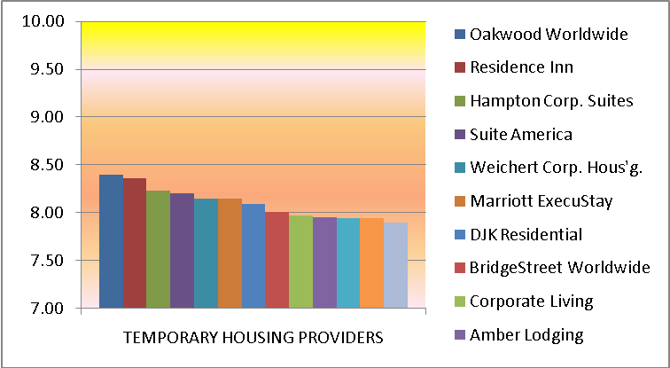

The chart shows moderate levels of differentiation on transferee satisfaction among the largest providers of temporary housing services.

Over a six-year period (see chart below) customer satisfaction reflects changing performance. Four of the five firms shown (other suppliers omitted for lack of historical data) realized improved results this year compared to last year. Oakwood shows the most consistent transferee satisfaction over the period, usually earning the top average score.
AVERAGE SCORES OVER 6 YEARS
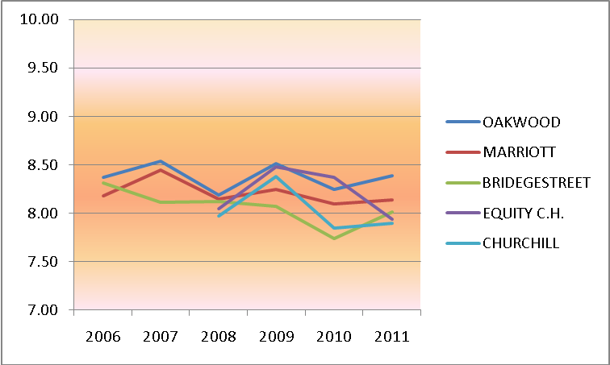

Over a long period the industry has shown relative flat transferee satisfaction performance after an early decade of improvement from “poor” to “average” results.

